**How to Create a Work Breakdown Structure**

Creating a work breakdown structure (WBS) helps you be both comprehensive and specific when managing a project: Thinking in detail is critical when planning your project, but you also need to consider the big picture. If you fail to identify a major part of your project’s work, you won’t have the chance to detail it. A work breakdown structure is key.

The diagram here shows that the entire project, represented as a Level 1 component, can be subdivided into Level 2 components, and some or all Level 2 components can be subdivided into Level 3 components.

You can continue to subdivide all the components in the same manner until you reach a point at which you think the components you defined are sufficiently detailed for planning and management purposes. At this point, you now have Level “n” components, where *n* is the number of the lowest-level component in a particular WBS branch. Level “n” components are called *work packages*.

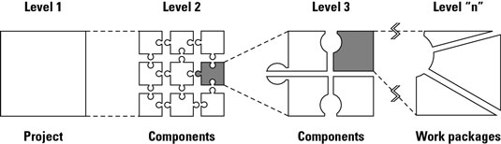

*Develop a work breakdown structure to determine the hierarchy of a project.*

Suppose you’re responsible for creating and presenting a new training program for your organization. To get started, you’d develop a WBS for this project as follows:

1. **Determine the major deliverables or products to be produced.**

Ask yourself, “What major intermediate or final products or deliverables must be produced to achieve the project’s objectives?”

You may identify the following items:

* + Training program needs statement
  + Training program design
  + Participant notebooks
  + Trained instructor
  + Program testing
  + Training program presentation

1. **Divide each of these major deliverables into its component deliverables in the same manner.**

Choose any one of these deliverables to begin with. Suppose you choose*Training program needs statement.*

Ask, “What intermediate deliverables must I have so I can create the needs statement?”

You may determine that you require the following:

* + Interviews of potential participants
  + A review of materials discussing the needs for the program
  + A report summarizing the needs this program will address

1. **Divide each of these work pieces into its component parts.**

Suppose you choose to start with *Interviews of potential participants*.

Ask, “What deliverables must I have to complete these interviews?”

You may decide that you have to produce the following deliverables:

* + Selected interviewees
  + Interview questionnaire
  + Interview schedule
  + Completed interviews
  + Report of interview findings